**LAB# 05**

**NAME: MUHAMMAD HASSAM KHAN**

**S.ID: 11141**

**Q1:**

**CODE:**

include Irvine32.inc

.data

star byte"*",0 lav1 dword 0,0

num dword 0,0

lav2 dword 0,0

lav3 dword "1"

.code main proc

sub ecx,ecx mov ecx,1

mov edx,offset lav3 call writestring

.while ecx<=9

mov lav1,2

.while lav1<=ecx mov eax,ecx

call writedec call writedec inc lav1

.endw call crlf mov lav2,1

mov ebx,ecx add ebx,1

.while lav2<=ebx

mov edx, offset star call writestring

inc lav2

.endw

call crlf inc ecx inc ecx

.endw

call waitmsg exit

main endp end main

# SCREENSHORTS:

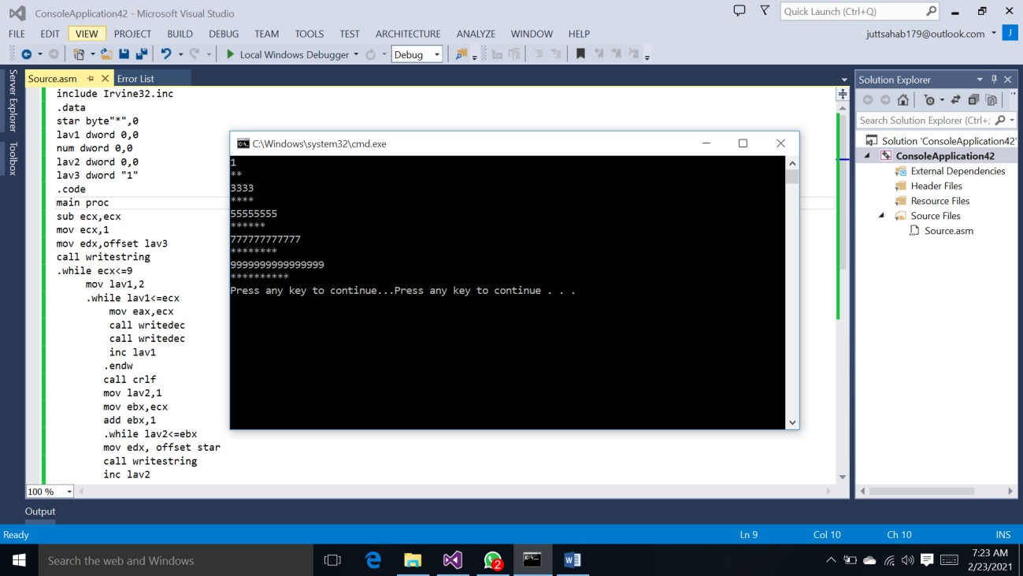

**Q2: CODE**

include Irvine32.inc

.data

star byte"**",0

|  |  |  |
| --- | --- | --- |
| **lav1** | **dword** | **0,0** |
| **lav2** | **dword** | **0,0** |
| **lav3** | **dword** | **0,0** |
| **lav4** | **dword** | **0,0** |

space byte " ",0

.code main proc mov ecx,1

.while ecx<=6 mov lav3,7

.while lav3>ecx

mov edx,offset space call writestring

dec lav3

.endw

mov lav1,1

.while lav1<=ecx mov eax,ecx call writedec call writedec inc lav1

.endw call crlf mov lav2,1

mov ebx,ecx add ebx,1 mov lav4,6

.while lav4>ecx

mov edx,offset space call writestring

dec lav4

.endw

.while lav2<=ebx mov edx,offset star call writestring inc lav2

.endw call crlf inc ecx

.endw

call waitmsg exit

main endp end main

# SCREENSHORTS:

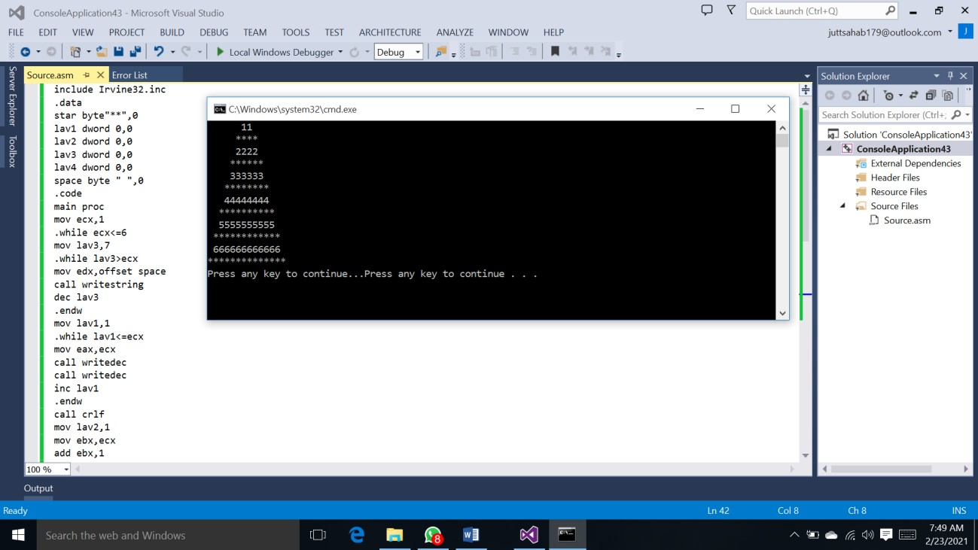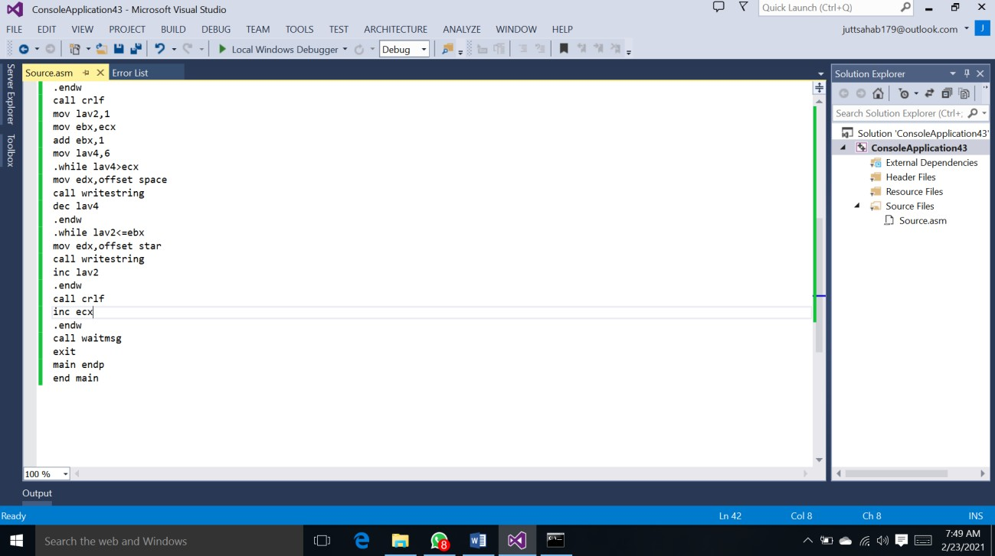

**Q3:**

**CODE:**

include Irvine32.inc

.data

space byte" ",0 star byte "*",0 m1 dword 0,0

m2 dword 0,0

m3 dword 0,0

m4 dword 0,0

m5 dword 0,0

m6 dword 0,0 line dword ?

sms byte"enter number",0dh,0ah,0

.code main proc

mov edx,offset sms call writestring call readint

mov line,eax mov ecx,1

.while ecx<=line mov m1,eax

.while m1>=ecx

mov edx,offset space call writestring

dec m1

.endw mov m3,2

.while m3<=ecx

mov edx,offset star call writestring inc m3

.endw mov m5,1

.while m5<=ecx

mov edx,offset star call writestring inc m5

.endw call crlf

inc ecx

.endw

mov ecx,1

.while ecx<=line mov m2,1

.while m2<=ecx

mov edx,offset space call writestring

inc m2

.endw

mov ebx,eax mov m4,ebx

.while m4>ecx

mov edx,offset star call writestring dec m4

.endw

mov m6,eax

.while m6>=ecx

mov edx,offset star call writestring dec m6

.endw call crlf inc ecx

.endw call waitmsg exit

main endp end main

# SCREENSHORTS:

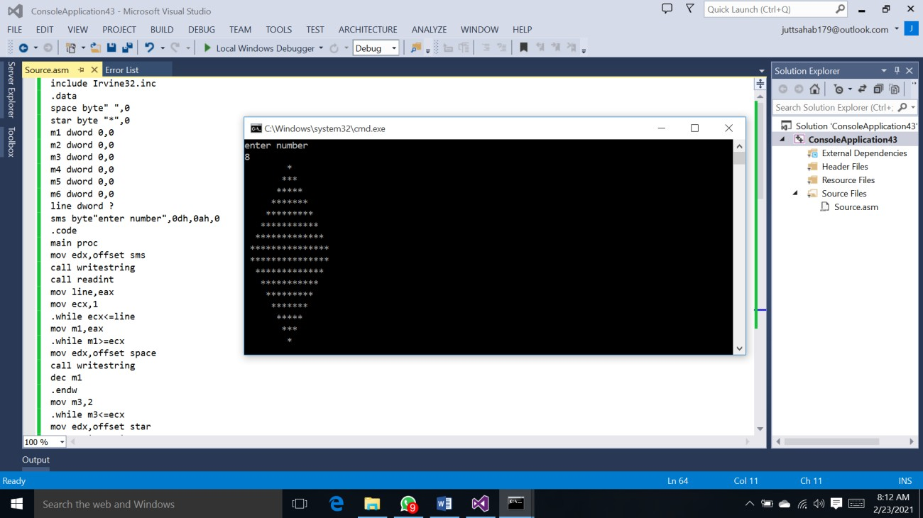

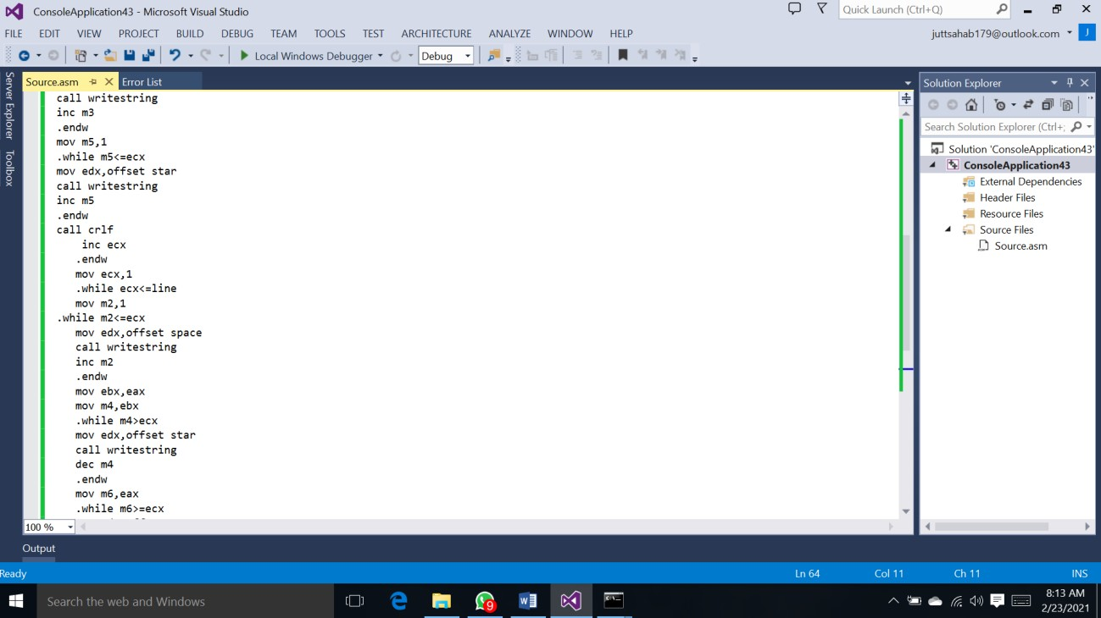

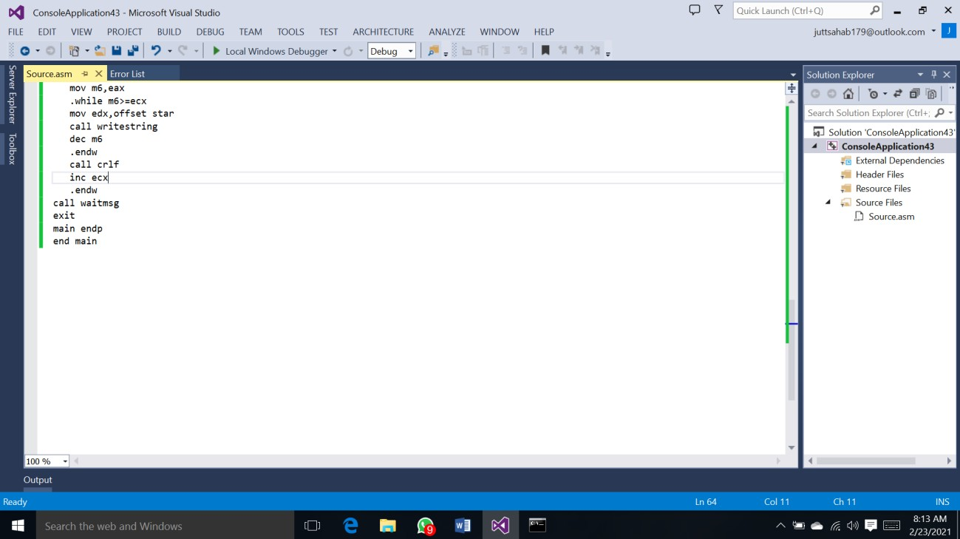

**Q4: CODE:**

include Irvine32.inc

.data

prime dword ? check dword 2

num1 dword 2

num byte"enter number",0 space byte" ",0

.code main proc

mov edx,offset num call writestring call crlf

call readint mov prime,eax loop1:

mov edx,0 mov eax,check mov ecx,num1

div ecx cmp edx,0

je checkprime inc num1

jmp loop1 checkprime: cmp eax,1

je printprime jmp notprime

printprime:

mov eax,check call writedec

mov edx,offset space call writestring

dec prime mov ecx,prime

notprime:

mov num1,eax inc check loop loop1 call waitmsg

exit

main endp end main

# SCREENSHORTS:

